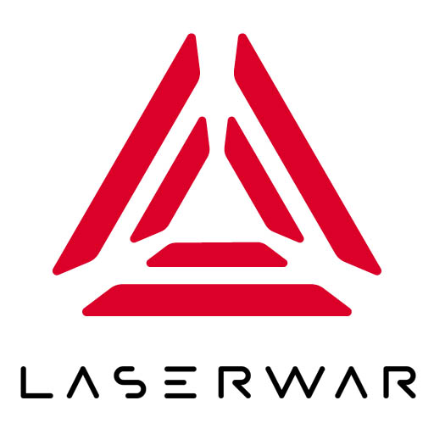
ОБЩЕСТВО С ОГРАНИЧЕННОЙ ОТВЕТСТВЕННОСТЬЮ
«ЛАЗЕРТАГ»

ПАСПОРТ

Смоленск
LIMITED LIABILITY COMPANY
LASERWAR

Smart PRO remote

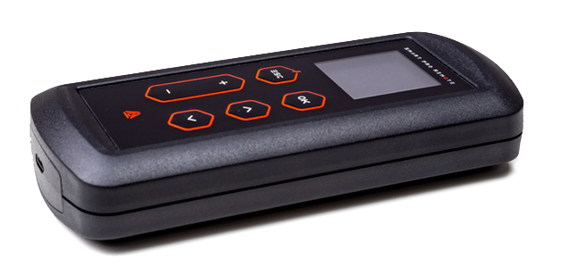

SPECIFICATION

Dear Customer!
Our company welcomes and thanks you for the decision to buy our products, and is confident that the purchased device will bring you a long-term pleasure. The warranty certificate establishes the guarantee of the product in the amount provided for by the Law on consumer protection of the Russian Federation.
This warranty certificate is valid for 12 months from the purchase date of the product, and is subject to the guarantee terms.
Warranty Terms:
1. The guarantee is effective upon presentation of this coupon, which shall contain the serial number of the product and the date of its purchase, confirmed by the service centre.
2. These guarantee obligations apply to products acquired only from the official LASERTAG representative or the official dealer.
3. The present guarantee is invalid if the product deficiencies have occurred in the following cases:
- failure to comply with Operating instructions;
- mechanical damage;
- penetration of extraneous items, liquids, etc.;
- animal activities;
- unauthorized access to the parts of the game set by non-authorized persons;
- use of the product for purposes for which it hasn't been made;
- Acts of elements (natural disaster, fire, accidents, etc.);
- the game set malfunction in case of faulty power network and/or poor care of the product.
4. If the warranty certificate is lost, no duplicate is issued.

9. Guarantee obligations
The manufacturer guarantees the reliability of the operation of an individual LASERWAR set if the consumer has complied with the conditions of use. Technical support is provided within 12 months of the sale date. The manufacturer undertakes to replace or repair an individual set of equipment free of charge, if the customer has complied with the rules for the device transportation, storage, operation and delivery of defective equipment to Smolensk City.
10. Contact information

Official website:
www.laserwar.com

E-mail: Purchase Date: _________________________
info@laserwar.com
help@laserwar.com

Skype:
info@laserwar.com
help@laserwar.com

______________________________________
signature

2
7
1. Description
The Smart PRO remote has 6 buttons to control laser tag equipment and change its performance characteristics, as well as an information LED display.

2. Scope of application
The device is designed for laser tag weapons remote control and is used in organizing sporting events, tactical exercises, corporate and recreational activities.
3. Contents of delivery
1. Remote control device - 1 pc.
2. USB cable - 1 pc.
3. Specification - 1 pc.

4. Basic technical Data
Length, mm | 130
Width, mm | 60
Thickness, mm | 25
Charger, B | micro-USB, 5V
Weight, gr | 125

5. The device
The Smart PRO remote has a plastic body of black color.
Inside the body there is a battery, control junctions, mounting hardware. The body has six control buttons, an IR diode, a photosensor, a power socket and an OLED display.

Information on the repairs performed during the maintenance period (completed by the Service centre performing the warranty repair works)

Date:__________________  Completed work: _____________________________________________________________________  Service centre stamp | Date:__________________  Completed work: _____________________________________________________________________  Service centre stamp
Date:__________________  Completed work: _____________________________________________________________________  Service centre stamp | Date:__________________  Completed work: _____________________________________________________________________  Service centre stamp
Date:__________________  Completed work: _____________________________________________________________________  Service centre stamp | Date:__________________  Completed work: _____________________________________________________________________  Service centre stamp

3
6
6. Maintenance
All parts of the set must be treated with care if you want the equipment to function properly. Avoid contamination and damage to the IR emitter and the photosensor. There shouldn't be any moisture inside the body. Charge the battery on time. Don't hit the device.

7. User's manual
All necessary information is shown on the OLED display. The top line of the screen has a standard charge indicator.
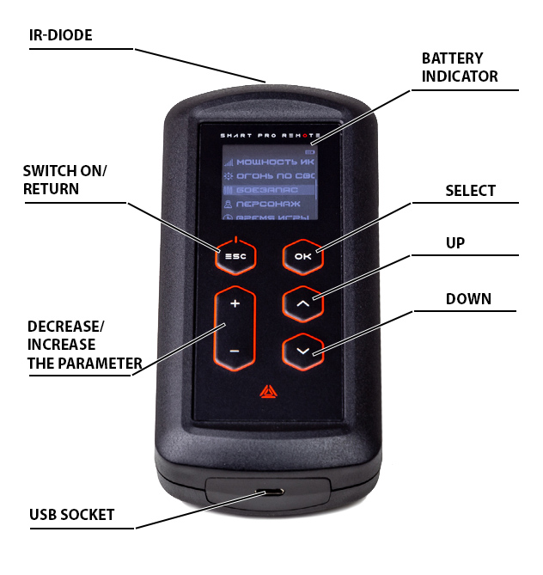
The "OK" button is used to confirm the command and the "ESC" button - to return to the previous level. Below there are two groups of buttons. The buttons "+" and "-" are used to increase/decrease the value of parameters, and the buttons "up" and "down" - to move the pointer through the menu items. Press the "ESC" button to turn the device on. The command is accompanied by a vibration pulse. Detailed work with the remote control is described in the "Operating Instructions."

8. Changing the device settings
Changing device settings is not supported.

Equipment Maintenance Rules
1. Weather conditions. At the course of manufacture we make different tests to see how well the equipment works under different weather conditions. Despite this, we strongly recommend that the equipment shouldn't be used in the rain and at temperatures below -20 °C.
What should I know when using the equipment in poor weather conditions?
The most important thing is to avoid getting moisture inside the device. If this happened, turn off the device, dry the equipment at room temperature for at least two hours.

The device must be charged with a micro-USB charger.

2. Power source. The Smart PRO remote game set uses a 2 Ah lithium battery as its power source.
It is necessary to store the equipment in a well-ventilated room at temperature from + 18 °C to + 30 °C and relative humidity of 45-65%.
The warranty is 14 days for speakers, and IR modules. These components are expendable materials.

WARNING! In the case of improper operation of the accumulator (charging by an unrelated type of a charger), the warranty doesn't cover the battery!

4
5

